March 09, 2017
Yama Olumi
Global Communications Manager
Business Line Oil Additives

Phone +1 215 706 5825
Fax +1 215 706 5801
yama.olumi@evonik.com

For immediate release:

From coal mining to construction, DYNAVIS® technology boosts efficiency worldwide
Every industry struggles to achieve the highest possible level of efficiency. The mining and construction industries are no different. And now, the construction industry is opening its eyes wide to the efficiency gains the mining industry is achieving from a technology called DYNAVIS® from Evonik Industries.
Construction, mining – different industries with one critically important power source in common – hydraulics. It’s true, of course, that the hydraulic power demands and the extreme working conditions of the mining industry often exceed those of the construction industry. For this reason, among others, construction industry leaders are beginning to consider the possibilities: “If DYNAVIS® technology brings higher levels of profitability to mining, imagine what it can do for construction,” they surmise.
At this year’s CONEXPO 2017 in Las Vegas, visitors to the DYNAVIS® exhibit will find all the evidence they need to support their switch from conventional hydraulic equipment fluids to those formulated to DYNAVIS® technology standards. From the numerous case studies developed from years of field tests to the online calculators that effectively predict fuel savings, the DYNAVIS® stand (#S64407) at CONEXPO 2017 will leave no stone unturned in telling the story of how viscosity-optimized hydraulic fluids can contribute to the efficiency of construction equipment.
It was only four months ago in a late-September Las Vegas that DYNAVIS® technology specialists presented their case to the thousands attending MINExpo 2016. Alongside the stands of OEMs producing hydraulic equipment for both mining and construction industries, the DYNAVIS® reps touted a technology that cuts fuel consumption per ton, shortens loading cycles and provides better trip efficiency.
Since then, the ongoing story of DYNAVIS® technology has added a new chapter to its growing volume of case studies and field tests. This one is from the subcontinent of India, a land of temperature extremes and challenging operating environments.
The DYNAVIS® Team selected one of India’s major global industrial groups as its partner in a DYNAVIS® technology trial that took place in a coal mining operation near Ranchi, India. In the open-pit mine, several hydraulic excavators are used to mine coal and roofing slate.
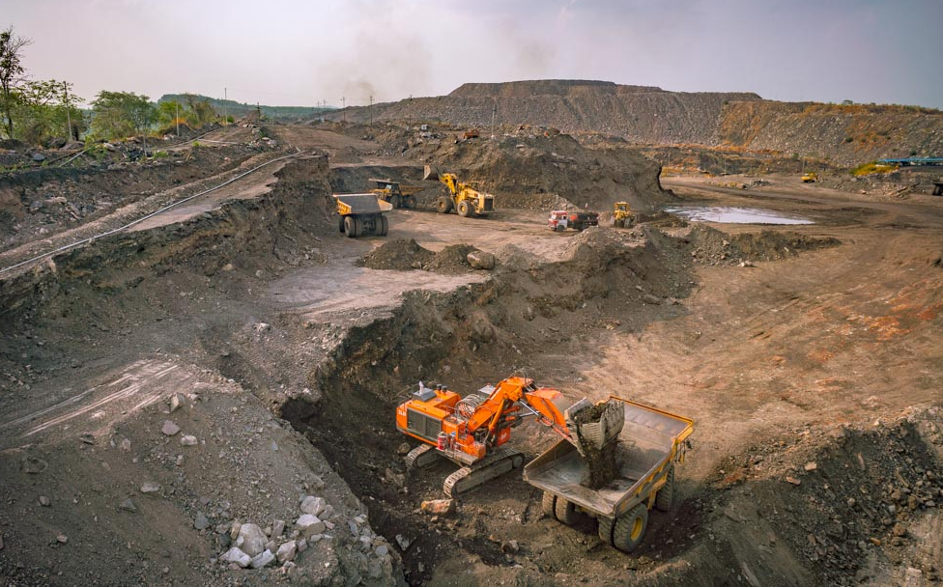
Indian coal mining operations near the city of Ranchi
A second partner in the test was the major Indian oil and lubricant marketing company. As a DYNAVIS® licensee, certified to blend hydraulic fluids that meet the DYNAVIS® standard and to carry the DYNAVIS® brand, they provided the DYNAVIS®-formulated fluid for the test.

The mining scenario: constantly working under pressure
The tested excavator was a standard piece of equipment in many mines throughout the world. It weighed 111 metric tons and was equipped with a 567 kW engine. At the coal mining operation, it is in continuous operation, working three shifts daily, 24/7.
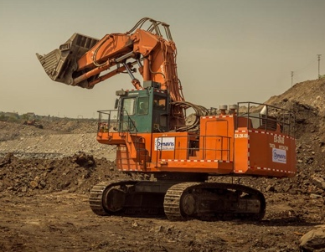
The hydraulic excavator, subject of the test
Track excavators are ideal test subjects, as they stay in one place for extended periods of time, working almost exclusively with their hydraulic system. In humid, sub-tropical locations like Ranchi, they are often subject to high temperatures, which compounds the stress inflicted by continuous operation. To obtain data under the most challenging conditions possible, the test took place in May, with average temperatures of 38 °C, the hottest month in Ranchi’s climate zone.
A tough competition
Before draining the 1100 liters of conventional hydraulic fluid from the excavator and refilling with DYNAVIS®-formulated fluid, it was determined that the drained fluid was of excellent quality, and would, therefore, provide a challenging reference fluid in a test comparison. Clearly, the difference in efficiency between these two fluids would be smaller than the difference between a low-quality hydraulic oil and the high-performance DYNAVIS®-formulated fluid.
Flawless testing accuracy
Testing was organized and conducted by a highly professional and skilled Evonik task force, specialized in the precise monitoring and recording of lubricant performance in a broad range of equipment.
Several highly accurate temperature sensors
were installed by the DYNAVIS® team on the
mining excavator tested.
Evonik’s Performance Test Lab Team installed precision temperature measuring devices at critical locations on the test excavator. The testing was conducted over a 9-day period under actual working conditions. Several dump trucks were put in service to the test excavator, carrying away about a crushing 75-80 MT load per trip.
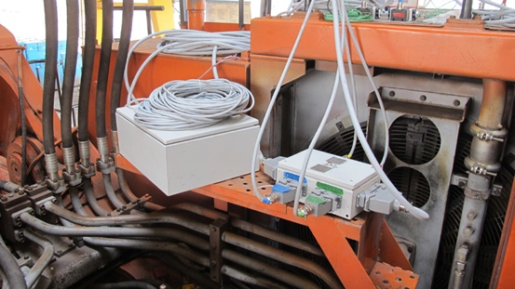
Calibrated flowmeters precisely recorded the
excavator’s fuel consumption.

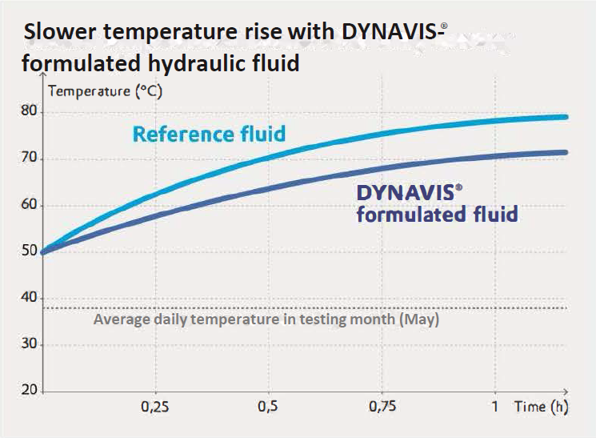
The temperature of the DYNAVIS®-formulated fluid rises more slowly, resulting in less temperature stress within the hydraulic pump and system. This reduces wear and tear, prolonging service life.
A ‘triple play’: more tons moved per liter of fuel, less time required per trip, and less fuel consumed per trip
Over the course of the testing, some 40,000 tons of material were moved – and more than 450 loading cycles were studied.
Numerous efficiency gains were observed with DYNAVIS®- formulated fluid flowing through the excavator’s hydraulic system. Fuel efficiency, measured in L/MT of material moved, improved by nearly 12.8 %. The excavator moved 12.2 MT of material per liter of fuel, compared to conventional fluid performance of only 10.8 MT. Time efficiency in minutes/trip improved by 11.8 %.
Finally, trip efficiency in liters of fuel/trip showed a gain of 10.6%.

Some facts on the fluids
The DYNAVIS®-formulated fluid had a viscosity grade of 46 and a viscosity index of 180. Its competitor had a viscosity index of 150 and was highly formulated, as outlined in the case study. Due to its higher viscosity index and better volumetric efficiency, the DYNAVIS®-formulated fluid was expected to outperform the reference fluid in terms of fuel efficiency. In fact, at high hydraulic fluid temperatures, the DYNAVIS® taskforce observed significantly better functionality for the DYNAVIS®-formulated fluid – yielding impressive fuel savings and efficiency gains. To read the entire case study, click here.

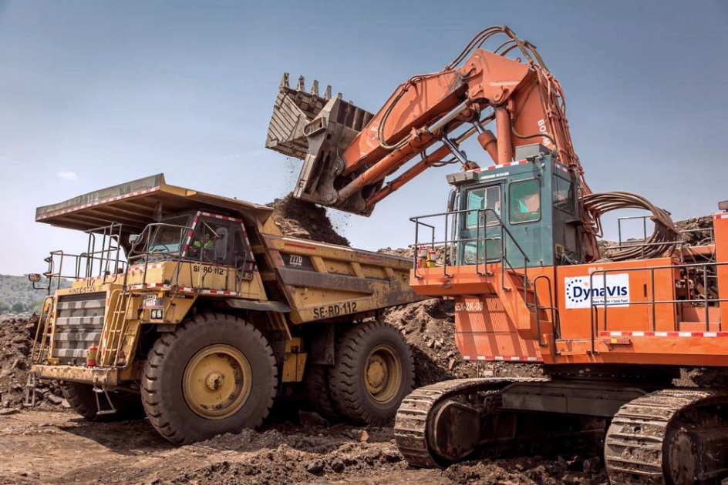
This coal mining operation in India experienced an efficiency gain of over 12% when their hydraulic system was drained and refilled with a hydraulic fluid formulated to the DYNAVIS® technology standard.

Company information
Evonik Industries, the creative international industrial group that developed DYNAVIS® technology, is one of the world leaders in specialty chemicals. Its activities focus on the key megatrends of resource efficiency, health, nutrition and globalization. Evonik benefits specifically from its innovative strength and integrated technology platforms. Evonik is active in over 100 countries around the world with more than 35,000 employees. In fiscal 2016 the enterprise generated sales of around €12,7 billion and an operating profit (adjusted EBITDA) of about €2.165 billion.

Disclaimer
In so far as forecasts or expectations are expressed in this press release or where our statements concern the future, these forecasts, expectations or statements may involve known or unknown risks and uncertainties. Actual results or developments may vary, depending on changes in the operating environment. Neither Evonik Industries AG nor its group companies assume an obligation to update the forecasts, expectations or statements contained in this release.

