July 3, 2017

Specialized Press Contact
Carolin Kather
Resource Efficiency
Phone +49 2365 49-9011
Carolin.kather@evonik.com

Evonik Resource Efficiency GmbH
Rellinghauser Straße 1-11
45128 Essen
Phone +49 201 177-01
Fax +49 201 177-3475
www.evonik.com

Supervisory Board
Dr. Ralph Sven Kaufmann, Chairman

Executive Board
Dr. Claus Rettig, Chairman
Dr. Johannes Ohmer,
Simone Hildmann,
Alexandra Schwarz

Registered Office: Essen
Register Court: Essen Local Court
Commercial Registry B 25783
VAT ID no. DE 815528487
Evonik bundels its expertise in crosslinking technology

- The Crosslinkers and Epoxy Curing Agents business will be combined to one new Business Line
- July 1 will be the first day of the new organization
- Global technology platform, long-term experience and profound expertise in crosslinker technology

Evonik Industries AG will combine its isophorone chemistry and epoxy curing agents business in the new Crosslinkers Business Line effective July 1, 2017. The newly formed Business Line, headed by Min Chong, will be part of the Resource Efficiency Segment.

With the acquisition of the Air Product's epoxy curing agents business and Evonik's long-time experience in isophorone chemistry, Evonik has a very broad technology platform and expertise in crosslinker technology.

The new Crosslinkers Business Line offers a broad range of products and competences for coatings and adhesives, civil engineering as well as for high-performance elastomers and composites.

Evonik is the pioneer in isophorone chemistry and covers the entire value chain: isophorone, diamine, as well as di-isocyanate and polyisocyanate.

Additionally the product portfolio contains a full tool box of amine curing agents for ambient and heat cure applications. The products are mainly used in industrial applications due to the mechanical strength, durability, chemical resistance and excellent adhesion properties.

“Combining both businesses to one new unit gives Evonik the chance to offer a variety of products for epoxy and polyurethane applications under one roof now – be it basic amines, isocyanate monomers, polyisocyanates or formulated epoxy hardeners”, Dr. Claus Rettig, Chairman of the Board of Management, Evonik Resource Efficiency GmbH.
“Apart from the organizational change, safety and meeting the needs of our customers continues to remain our first priority”, Min Chong, head of the new Business Line Crosslinkers. “We see ourselves as a partner; interested in developing next-generation product solutions together with our customers. A broad technology platform serves as the basis for further growth and successful collaboration.”

The Business Line has a total of about 1.000 employees worldwide. Production facilities in Europe, North America, and Asia ensure optimal proximity to markets and customers and open up attractive growth opportunities.

The Crosslinkers portfolio contains strong brands:

Amicure®, Ancamide®, Ancamine®, Ancarez®, Ancatherm®, Anquamine®, Anquawhite®, Curezol®, Dicyanex®, EplinkTM, Epodil®, Hybridur®, Imicure®, Nourybond®, Sunmide®, VESTAGON®, VESTAMIN®, VESTANAT®, VESTASOL®
www.evonik.com/crosslinkers

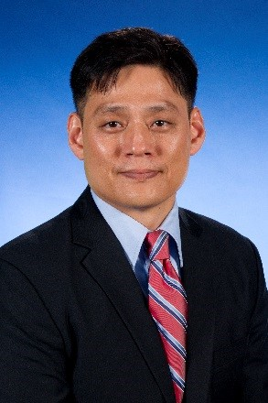
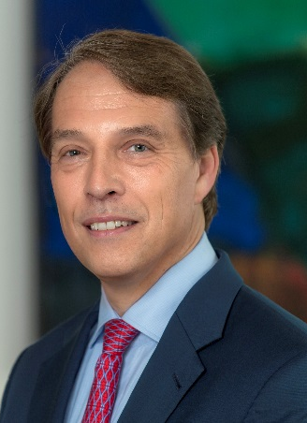

Claus Rettig Min Chong

Chairman of the Board of Management Head of the Business Line Crosslinkers
Evonik Resource Efficiency GmbH Evonik Resource Efficiency GmbH

About Resource Efficiency
The Resource Efficiency segment is led by Evonik Resource Efficiency GmbH and supplies high performance materials for environmentally friendly as well as energy-efficient systems to the automotive, paints & coatings, adhesives, construction, and many other industries. This segment employed about 9,000 employees, and generated sales of around €4.5 billion in 2016.

Company information
Evonik is one of the world leaders in specialty chemicals. The focus on more specialty businesses, customer-orientated innovative prowess and a trustful and performance-oriented corporate culture form the heart of Evonik’s corporate strategy. They are the lever for profitable growth and a sustained increase in the value of the company. Evonik benefits specifically from its customer proximity and leading market positions. Evonik is active in over 100 countries around the world with more than 35,000 employees. In fiscal 2016, the enterprise generated sales of around €12.7 billion and an operating profit (adjusted EBITDA) of about €2.165 billion.

Disclaimer
In so far as forecasts or expectations are expressed in this press release or where our statements concern the future, these forecasts, expectations or statements may involve known or unknown risks and uncertainties. Actual results or developments may vary, depending on changes in the operating environment. Neither Evonik Industries AG nor its group companies assume an obligation to update the forecasts, expectations or statements contained in this release.

